Chafing dish ZCK100S
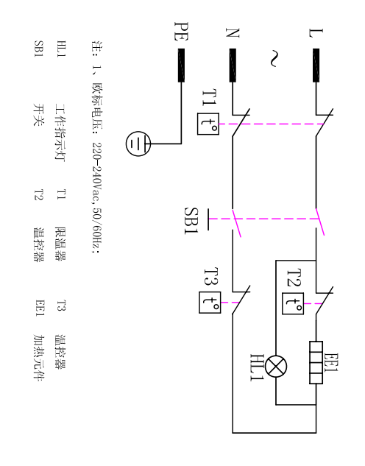

HL1: indicator light T1 temperature limiter T3 thermostat
SB1 on-off switch T2 thermostat EE1 heater

